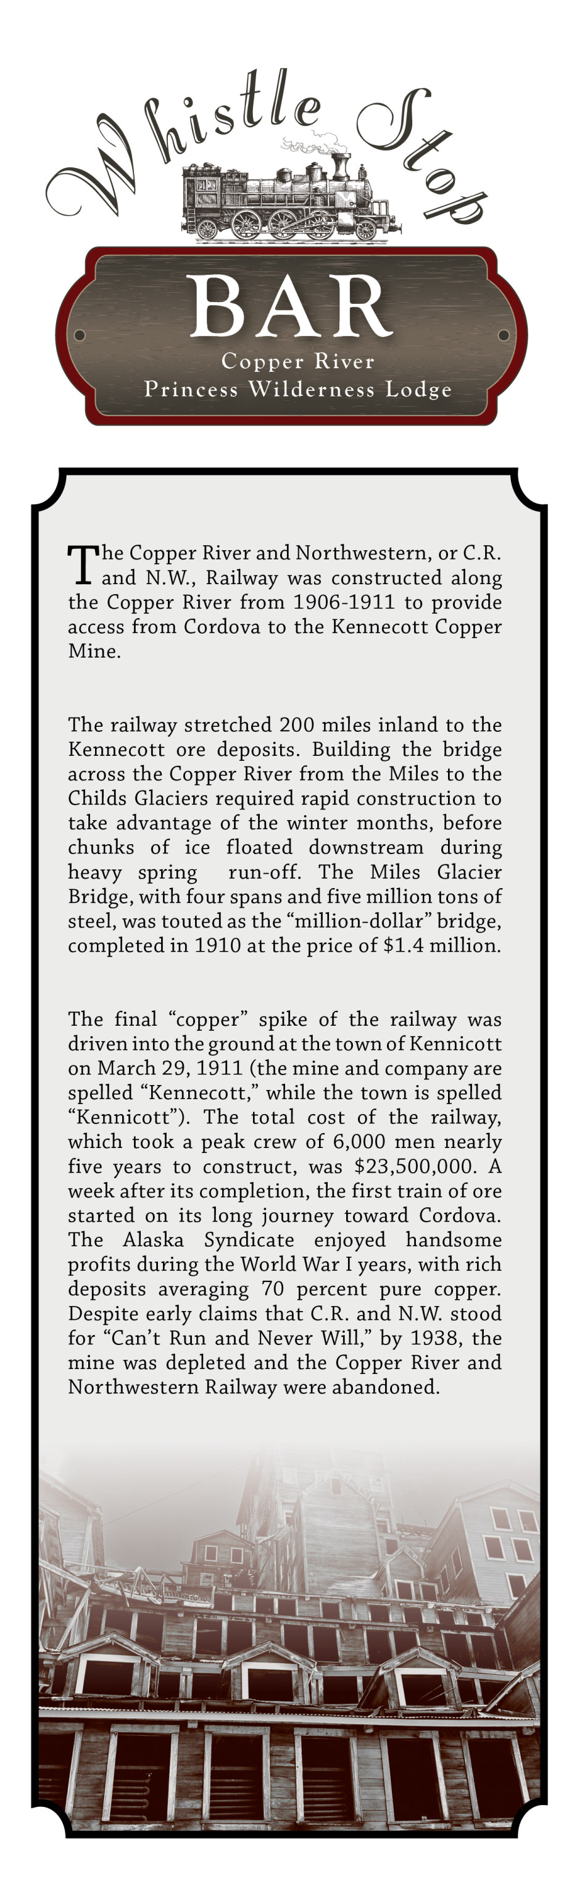



Soup of the Day

*Cup – 6 Bowl – 8*

Wild Alaska Smoked

Salmon Chowder

*Roasted red pepper, cream, potatoes, garlic, onion, celery, cream and traditionally smoked wild Alaska salmon.*

*Cup – 6 Bowl – 8*

Classic Caesar Salad

*Romaine, parmesan, garlic croutons and Caesar dressing.*

*Side – 7 Entrée – 11*

*Add chicken or smoked salmon – 6*

*Add grilled salmon – 10*

The Copper Spike C:\Users\pt07394\AppData\Local\Microsoft\Windows\Temporary Internet Files\Content.Outlook\GMIWBZMF\Gold Wheat .15in (003).png

*Mixed seasonal greens, tomatoes, cucumbers and carrots, tossed with a raspberry vinaigrette dressing.*

*Side – 7 Entrée – 11*

*Add chicken or smoked salmon – 6*

*Add grilled salmon – 10*

Sesame Chicken Salad

*Fresh mixed greens, grilled chicken breast, cherry tomatoes, peppers, orange segments, carrots, snow peas, cabbage and crispy rice noodles, tossed with sesame vinaigrette in a crispy shell. 18*

Homestead Wings

*Crispy chicken wings and drumettes served with celery, carrots and bleu cheese dressing. Your choice of traditional buffalo style, garlic parmesan or copper gold. 14*

Copper River Auger

*Spiral cut potatoes, bacon and molten cheese sauce, topped with candied jalapenos, green onions, sour cream and crumbled bacon. 13*

NW Ploughman’s Platter C:\Users\pt07394\AppData\Local\Microsoft\Windows\Temporary Internet Files\Content.Outlook\GMIWBZMF\Gold Wheat .15in (003).png

*Alaska caribou sausage, hard salami, herb encrusted goat cheese, Dubliner cheese and a specialty cheese, served with spiced pecans, stone ground mustard and toasted crostini. 14*

Jumbo Prawn Cocktail C:\Users\pt07394\AppData\Local\Microsoft\Windows\Temporary Internet Files\Content.Outlook\GMIWBZMF\Gold Wheat .15in (003).png

*Seasoned sweet white prawns served with our house made cocktail sauce. 14*

Chitina Cheese Curds

*Alaska style deep fried cheese curds and seasoned artichoke hearts served with pesto ranch. 13*

Soup & Salad

Starters

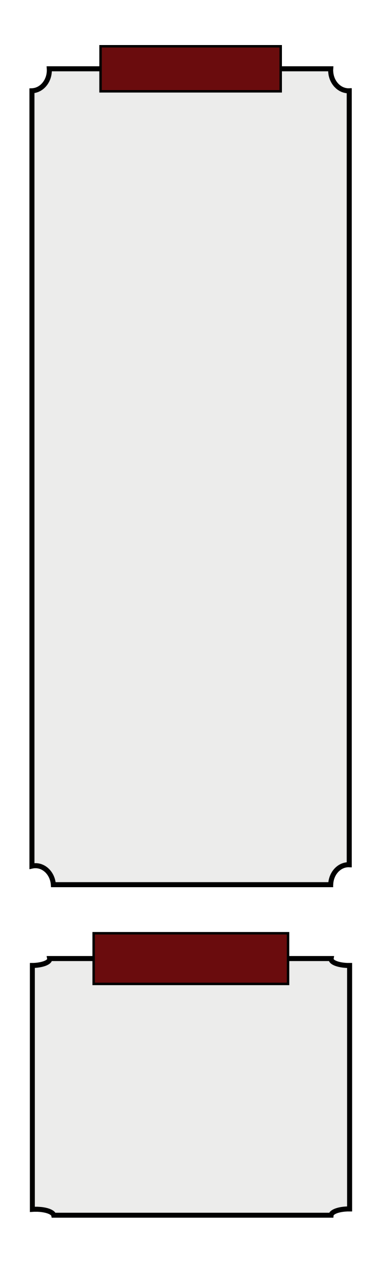

Conductor’s Cheeseburger C:\Users\pt07394\AppData\Local\Microsoft\Windows\Temporary Internet Files\Content.Outlook\GMIWBZMF\Gold Wheat .15in (003).png 

*Half pound Angus beef patty with cheddar cheese, lettuce, tomato, onion and house sauce on a toasted parmesan black pepper bun, served with French fries. 14*

Gold Rush Burger C:\Users\pt07394\AppData\Local\Microsoft\Windows\Temporary Internet Files\Content.Outlook\GMIWBZMF\Gold Wheat .15in (003).png 

*Handmade reindeer and beef patty, cheddar cheese, bacon jam, frizzled onions, pesto mayo, tomato, onion and lettuce on a parmesan black pepper bun, served with French fries. 19*

Mount Drum Dip C:\Users\pt07394\AppData\Local\Microsoft\Windows\Temporary Internet Files\Content.Outlook\GMIWBZMF\Gold Wheat .15in (003).png

*Slow cooked prime rib and provolone cheese on a toasted French roll, served with French fries and au jus. 16*

*Add peppers and grilled onions - 1*

Klutina Chicken Club C:\Users\pt07394\AppData\Local\Microsoft\Windows\Temporary Internet Files\Content.Outlook\GMIWBZMF\Gold Wheat .15in (003).png 

*Lemon herb grilled chicken breast, Swiss cheese, cucumbers, tomatoes, bacon, arugula and guacamole on a Telera roll, served with French fries. 15*

The Caboose C:\Users\pt07394\AppData\Local\Microsoft\Windows\Temporary Internet Files\Content.Outlook\GMIWBZMF\Gold Wheat .15in (003).png

*Balsamic marinated Portobello mushroom, fresh mozzarella, basil, tomatoes, roasted red pepper, arugula and olive tapenade on a Telera roll with balsamic herb aioli, served with a side salad. 14*

Salmon BST C:\Users\pt07394\AppData\Local\Microsoft\Windows\Temporary Internet Files\Content.Outlook\GMIWBZMF\Gold Wheat .15in (003).png 

*Grilled salmon filet with tomato, bacon and apple slaw on a Telera roll, served with French fries. 16*

Buffalo Chicken Wrap

*Crispy chicken tenders tossed in buffalo sauce, romaine, celery and bleu cheese dressing in a garlic herb tortilla, served with French fries. 14*

Copper River Special

*Chef’s choice sandwich of the day served with a cup of soup. 15*

Sandwiches

Miner’s Ribs

*A half rack of hickory smoked pork spare ribs smothered in a spiced BBQ sauce, served with French fries and coleslaw. 26*

Fish and Chips

*Panko breaded pacific cod with French fries, lemon wedge and tartar sauce.*

*Two pieces – 14 Three pieces - 16*

Classics



White Chocolate

Raspberry Cheesecake

*Silky smooth white chocolate cheesecake swirled with vibrant red raspberries. 8.5*

Chocolate Toffee

Mousse Cake

*Rich and creamy dark chocolate mousse with a ribbon of toffee bits in a chocolate cookie crust, served with whipped cream. 8.5*

Gluten Free Chocolate Torte C:\Users\pt07394\AppData\Local\Microsoft\Windows\Temporary Internet Files\Content.Outlook\GMIWBZMF\Gold Wheat .15in (003).png

*Rich, dense flourless chocolate cake, served with a dollop of whipped cream. 8.5*

Tillamook Ice Cream

*A scoop of Pacific NW made mountain huckleberry or vanilla bean. 4*

Fruit Bowl C:\Users\pt07394\AppData\Local\Microsoft\Windows\Temporary Internet Files\Content.Outlook\GMIWBZMF\Gold Wheat .15in (003).png

*Fresh cut melon, pineapple & seasonal berries 7.5*

Salmon En Papillote C:\Users\pt07394\AppData\Local\Microsoft\Windows\Temporary Internet Files\Content.Outlook\GMIWBZMF\Gold Wheat .15in (003).png 

*Lightly seasoned Alaska salmon*

*baked in parchment with herb & citrus gremolata butter over seasonal vegetables,*

*served with rice pilaf. 28*

St. Elias Chicken C:\Users\pt07394\AppData\Local\Microsoft\Windows\Temporary Internet Files\Content.Outlook\GMIWBZMF\Gold Wheat .15in (003).png 

*10oz chicken breast spice rubbed, seared until crisp and topped with rhubarb thyme compote, served with herbed rice pilaf and fresh vegetable. 26*

Herb Encrusted Rockfish

*Pan seared rockfish encrusted with an herb breading and topped with a light lemon herb sauce, served on a bed of seasoned wild rice pilaf with fresh vegetable. 29*

Charred Vegetable Wellington

*House made, with a marinated and charred mixture of Portobello mushroom, onions, yellow squash, zucchini and roasted red peppers baked in puff pastry dough, served with wild rice pilaf and fresh vegetable. 26*

5pm-9pm

Dessert

 *Consuming raw or undercooked meats, poultry, seafood, shellfish*

*or eggs may increase your risk of foodborne illness.*